*LIGO Laboratory / LIGO Scientific Collaboration*

**LIGO** *LIGO* 05/28/2025

Standard Operating Procedure

for the 2.1 W, 1560nm NP Photonics Rock High Power Laser Source; 45mW, 780nm Thorlabs Butterfly DBR Laser; and Covesion WG-1560-40 Second Harmonic Generator  
in East Bridge B111

Torrey Cullen and Lee McCuller

Updated by Daniel Grass

Distribution of this document:

Lasers and Optics

This is an internal working note

of the LIGO Project.

|  |  |
| --- | --- |
| **California Institute of Technology**  **LIGO Project – MS 100-36**  **1200 E. California Blvd.**  **Pasadena, CA 91125**  Phone (626) 395-2129  Fax (626) 304-9834  E-mail: info@ligo.caltech.edu | **Massachusetts Institute of Technology**  **LIGO Project – NW22-295**  **Cambridge, MA 02139**  Phone (617) 253-4824  Fax (617) 253-7014  E-mail: info@ligo.mit.edu |
| **LIGO Hanford Observatory**  **P.O. Box 159**  **Richland WA 99352**  Phone 509-372-8106  Fax 509-372-8137 | **LIGO Livingston Observatory**  **P.O. Box 940**  **Livingston, LA 70754**  Phone 225-686-3100  Fax 225-686-7189 |

http://www.ligo.caltech.edu/

# Introduction

This document is the Standard Operating Procedure (SOP) for the 45mW, 780nm Thorlabs Butterfly DBR Laser (DBR780PN), 2.1 W, 1560nm NP Photonics Rock High Power Laser Source (the “Rock”), and Covesion WG-1560-40 Second Harmonic Generator in East Bridge B111. This laser system is used for the operation of RbQ experiment.

The Rock has an output at 1560 nm, with nominal operating output power of 2.1 W. This is a class IV laser. The Rock is an integrated seeder (40 mW output) and amplifier (2.1 W output) on a 19” rack mountable platform.

The DBR780PN is a Class 3B, distributed Bragg reflector (DBR) laser system with output at 780 nm, with an absolute maximum output of 45mW. The DBR780PN is a butterfly-packaged pigtail distribution laser.

We will be using up to 150 mW of 780 nm light from a Covesion WG-1560-40 Second Harmonic Generator. This is a class 3B laser hazard. The Covesion WG-1560-40 is a free space crystal the converts 1560 nm light to 780 nm light.

## Room B111

The floor plan of East Bridge B111 is shown in Figure 1. **The grey area indicated by waves is the Nominal Hazard Zone.** The area between the laser safety barrier (curtains) and the entrance door is non-hazard area that is designated for storing and donning laser safety glasses.

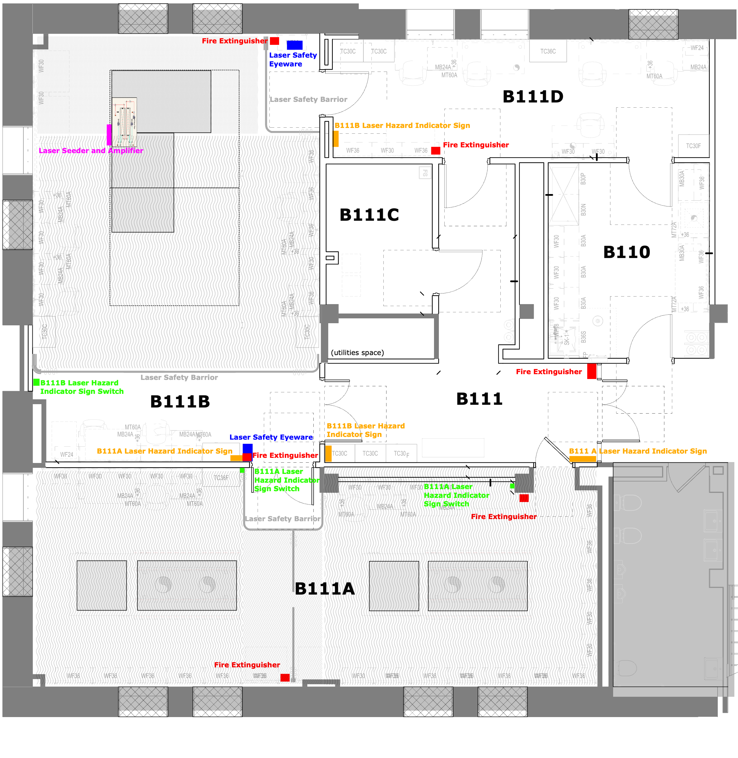

Figure 1. The floor plan for Room B111.

# Hazards

## Laser Radiation Hazards

All laser light used is infrared and is invisible to the naked eye. The output power each laser can be operated above the accessible emission limit (AEL) for both eye and skin. Extreme caution should be taken when operating the lasers. The AEL for 780 nm light is 0.56 mW and the AEL for 1560 nm light is 9.6 mW

## Electrical Hazards

The lasers are powered with a standard wall outlet. *There are no electrical hazards when operating the laser.*

## Fire Hazards

Operating the Rock Laser at powers on the order of 2 W has the potential for fire. Ensure the beam is only directed at approved optics equipment or qualified beam dumps. **Check Figure 1 for fire extinguisher location.** Fire extinguisher #21957.

# Hazard Controls

## Access Controls

There are no active access controls to East Bridge Room B111.

Access to laser areas requires a key card and physical key.

An interlock will be added.

## Beam Controls

The Rock Laser seeder requires a key turn and switch flip to be enabled even if it is already powered on. The amplifier requires an additional flip of a switch and an input on a connected computer to increase the current supply. The DBR780PN requires a physical button to be pushed to enable the laser and further input to increase the current.

## Laser Interlock

The Rock laser has an included interlock connector. This BNC must be shorted for normal operation. When the terminals are open circuit the laser will automatically be in a shutdown state. An included 50 Ω terminator can be used to bypass the laser interlock.

## Safety Sign

## Laser hazard indicator signs are located at the outside of the rooms. Whenever there is a possibility to use the laser beam for a task, this sign shall be turned on by a switch. See Figure 1 for the switch locations. At least temporarily while the signs don’t have a button, a removable placard shall be hung at the entrance to B111A and B111B if the laser signs aren’t illuminated.

## Laser Safety Eyewear

The use of laser safety eyewear is mandatory whenever the laser power supply is energized. If the DBR780PN alone is in use, a minimum optical density (OD) of 3 at 780 nm is required (OD 1.9 absolute mathematical minimum with a required safety factor of OD 1.1). When the Rock is in use, a minimum of **OD 4 at 1560nm is required** (OD 2.4 absolute mathematical minimum with a required safety factor of OD 1.6). 200 mW of 780 nm light will be used, although the maximum Covesion SHG output is 650 mW when powered by the Rock. Therefore, a minimum of **OD 4 at 780 nm is required** (OD 3.1 absolute mathematical minimum with a required safety factor of OD 0.9). Phillips Safety C2KG5 laser safety goggles will be stored in the entrance area. These goggles have filtering at the following wavelengths:

OD 6+ @530-570nm  
OD 4+ @655-664nm  
OD 5+ @665-679nm  
OD 6+ @680-695nm  
OD 7+ @696-1550nm

OD 4+ @1551-2750nm (OD 6+ from 1550 to 1600+ nm according to Figure 2, from Phillips Safety)

Figure 2. C2KG5 laser safety goggle OD as a function of wavelength (nm)

Always double check the listed filtering on the side of the goggles before entering the laser hazard area and ensure there are no scratches or cracks in the goggles.

Please note the comfortable safety margin of OD 4 required vs. OD 7 for the goggles. These goggles pass through a lot of visible light, so we encourage but do not require the use of goggles in the areas separated from the lasers with curtains.

## Handling of the optical fiber

The lasers output via a PM, FC/APC optical fiber. The Rock laser amplified output fiber and fiber collimator should not be removed. Other optical fibers will be used with up to 150 mW. Use extreme caution, ensure 90%+ coupling efficiency into the fiber, and do not adjust the output of fiber with any power going through the fiber.

# Training

Users of the DBR780 PN and Rock laser and Covesion SHG should have received the Caltech basic laser safety training. They are not permitted to operate the laser by themselves until they have received this training.

# Operating Procedures

The following section describes how to turn on the appropriate seeder laser and amplifier. Items such as jewelry and watches should not be worn while manipulating beams on the optical table. Caution should be exercised when one’s head passes through the plane of the laser beam.

## Steps prior to turning on a laser:

* Check the beam path to ensure that there are no reflective objects in the beam path that may unintentionally deflect the beam or burn
* Alert any personnel in the room that the laser is about to be operated and ensure that everyone is wearing the appropriate laser safety eyewear
* Check that the laser warning signs are illuminated and the physical warning signs are placed
* Ensure the doors into B111A and B111B are shut and locked
* Ensure curtains are closed
* Ensure the window shades are closed
* Place tape over the B111A to antechamber door handle on both sides as this door is only to be used in emergencies until laser curtains are installed
* Please make a courtesy electronic notification (via Mattermost or email) and log post

## Rock Laser

## Initially setting up the Rock Laser

* Mount the laser on a 19” Electronics rack. Be careful with the fiber(s) coming off of the laser
* The amplifier output fiber and fiber collimator should never be removed. Mount the included fiber collimator
* Make sure the AC power entry is set to the off position
* Make sure the system power key switch is in the O (Off) position (vertical)
* If the seeder laser will be used, plug in a PM FC/APC fiber and output collimator to the seeder laser
* Plug in the USB-A cable to a computer that goes to the RS232 port on the laser
* Install the laser control software
* Make sure the remote interlock connector is short circuit or a 50 Ohm terminator (included) is fitted to the interlock BNC
* Connect a BNC to the fast piezo modulation BNC on the rear panel

## Turning on the Rock Laser

* Make sure the system power key switch is in the O (Off) (vertical) position
* Turn on the laser control software
* Turn on the AC power on the back of the laser if it is not already on
* Turn the key switch on the front of the panel from off to on (90° clockwise into a horizontal position). A green indicator LED will light up
* Connect to the laser via the startup window using the auto-find and the relevant port (COM4 was the port used last time)
* Wait 10 minutes for the seed laser temperature to stabilize. Turn on the seed output switch. Another green indicator LED, this one above the seed laser’s optical output, will light up. The amplifier will also output power, but only ~200 μW**.**
* Wait another 15-20 minutes for the seed laser to restabilize
* Turn on the amplifier output switch. The Amplifier Enable LED will come on. If the amplifier is attempted to be turned on before the seed laser is stable, the amplifier will be in a disabled state until the seed laser is ready

## Increasing the Rock Laser Output Power

* Turn on the laser control software and connect to the laser if you haven’t already
* Go to the “ACC” mode in the amplifier panel on the right and slowly increase the current by dragging the vertical bar or inputting a current. Meaningful amplification (above 1 mW) should not happen below 0.40 A
* “APC” mode should also work but hasn’t been tested
* At 5.21 Amps given to the laser, the laser reported an output power of 1.7 Watts.

## Shut down Procedure for the Rock Laser

* Using the GUI, slowly (<0.05 A/s or 0.1 W/s) reduce the amplifier output to the minimum output
* Disable the amplifier output on the laser. The Amplifier Enable LED will turn off
* Disable the seeder output on the laser. The seed output indicator LED should turn off
* Turn the system power key switch to off (90° counterclockwise into a vertical position). The green indicator LED should turn off
* If putting away/not using for a while, turn the AC power switch in the back of the unit to off

## DBR780PN Butterfly Laser

## Initially setting up the DBR780PN (based on [McCuller eLog 11712](https://mccullerlab.com/logs/lab/index.php?callRep=11712))

* Put on an ESD strap and plug it into the universal 14-Pin Butterfly Laser Diode Mount LM14S2
* Place the configuration card for the Type 1 laser into the LM14S2 mount
* Unclasp and lift the mount’s latches and place the DBR780PN on top of the pins. The dot on the DBR780PN should align with pin 1
* Gently screw the laser into the mount
* Put down the mount’s latches clasp them to secure the electrical connections
* Attach the PM fiber output to a collimator and block the output/ensure the output is going where intended
* Plug in the laser temperature (TED200C) and laser current (LDC205C) controller to the wall outlet and to the LM14S2 mount

## Turning on the DBR780PN (based on [McCuller eLog 11712](https://mccullerlab.com/logs/lab/index.php?callRep=11712))

* Turn on the laser current controller
* Set the current maximum to 250 mA as this is the DBR780PN maximum current
* Turn on the laser with the button on the top right of the laser current controller. A green “laser on” LED should illuminate on the current controller and the LM14S2 mount
* Increase the current to 230 mA and the power should increase to 39.6 mW
* Set 230 mA (or a close value) to the new maximum current output
* Turn on the laser temperature controller
* Go to home, thermistor calibration, change the calculation method to the Steinhart-Hart and enter the spec values for this specific laser:
  + Steinhart-Hart A: 1.129E-3
  + Steinhart-Hart B: 2.341E-4
  + Steinhart-Hart C: 0.088E-6
* Set the temperature to 25°C?

## Turning off the DBR780PN

* Press disable on the button on the top right of the laser current controller. The green “laser on” LEDs should turn off on the current controller and the LM14S2 mount

## Storing the DBR780PN

* Ensure the laser is off
* Turn off and unplug the laser controllers from the mount and wall outlet
* To remove the laser, press down on the mount’s latches, unclasp and lift them, and lift the latches
* Unscrew the laser from the mount
* Lift the laser from the mount

# Emergency Procedures

In case of an emergency, call x5000.

To turn the laser off quickly but without damaging equipment, turn the key on the Furman Power Conditioner from On to Off

Follow the emergency response guide.